CHAPTER 5

RESULTS AND DISCUSSION

Trend Analysis

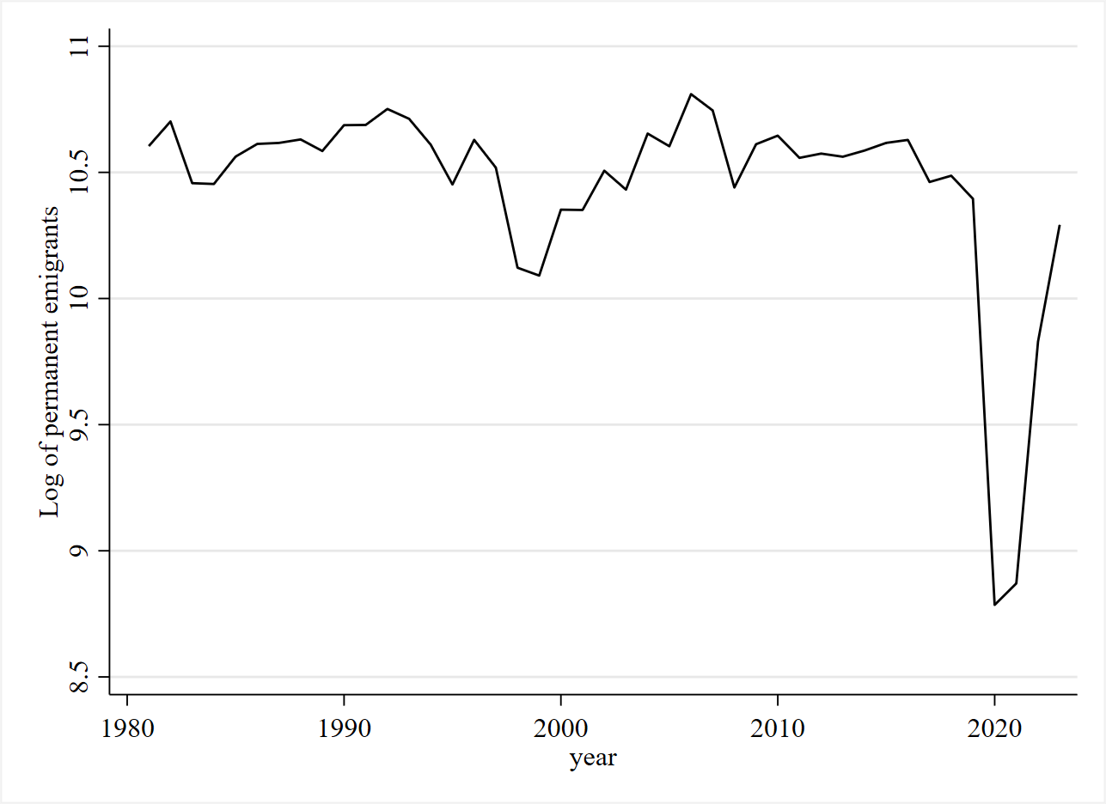
Figure 1a. Log of Philippine emigration, 1981–2023

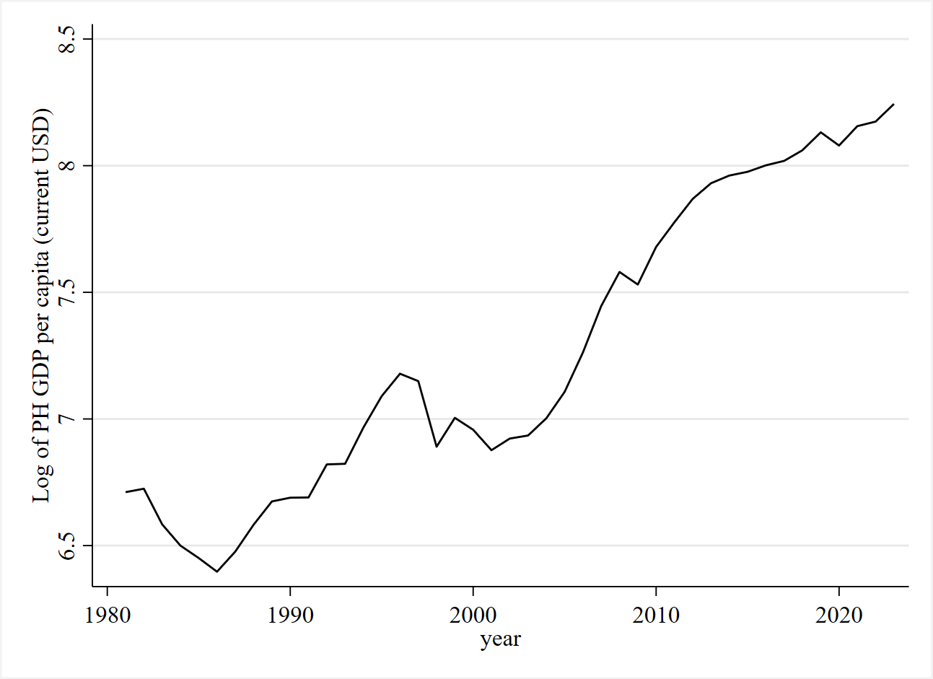
Figure 1b. Log of Philippine real GDP per capita, 1981–2023

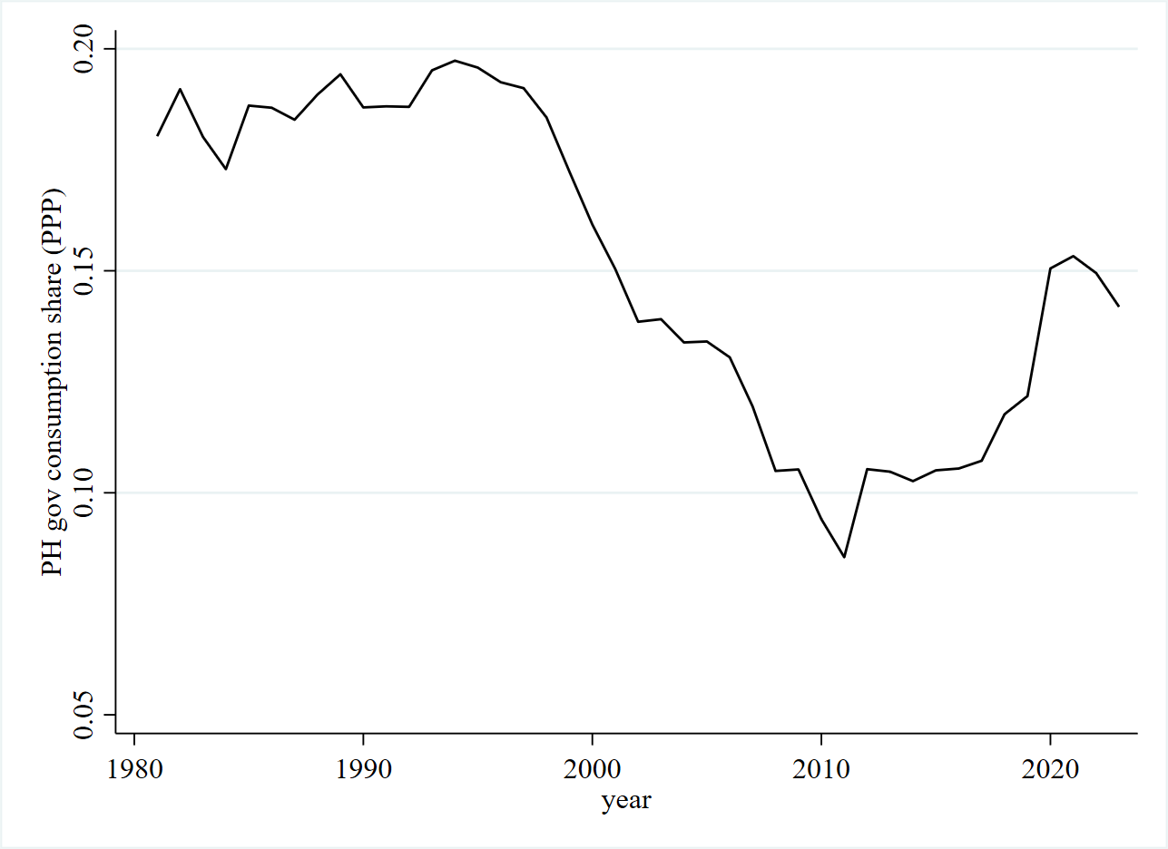
Figure 1c. Philippine government consumption share, 1981–2023

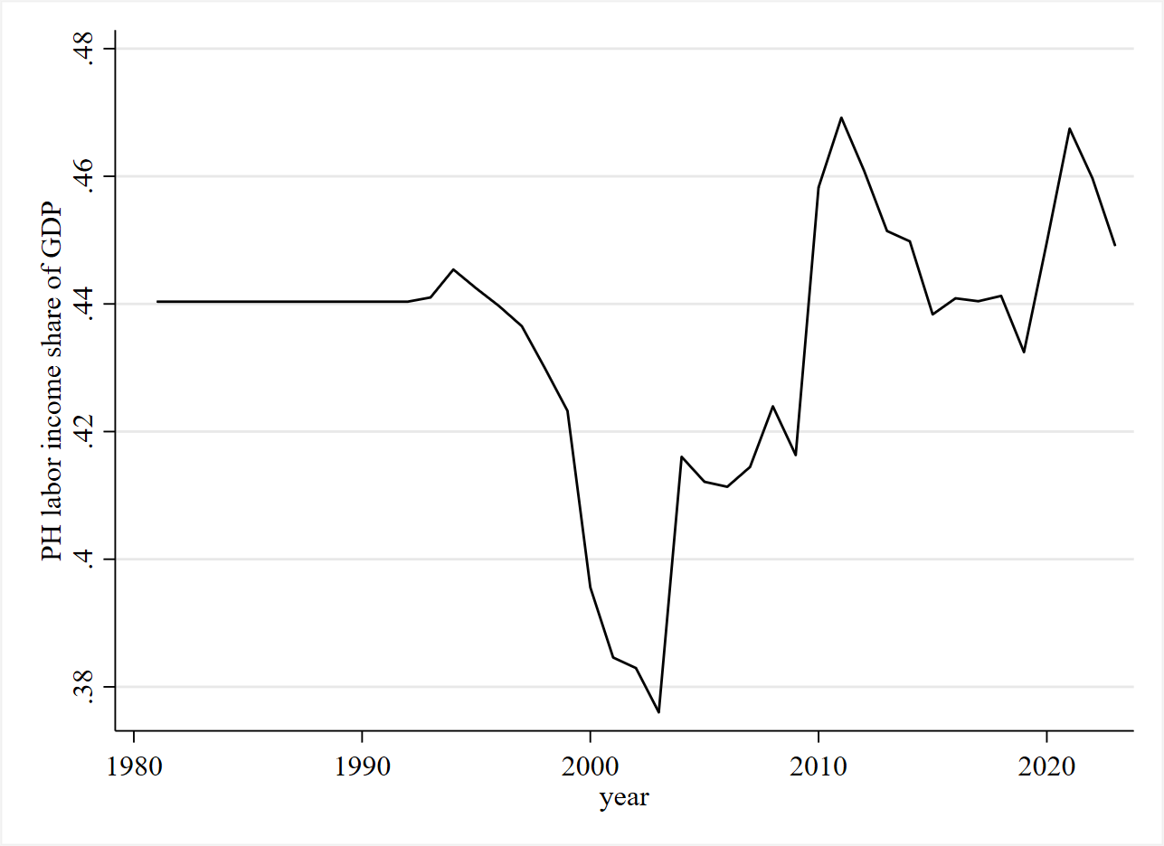
Figure 1d. Philippine labor income share, 1981–2023

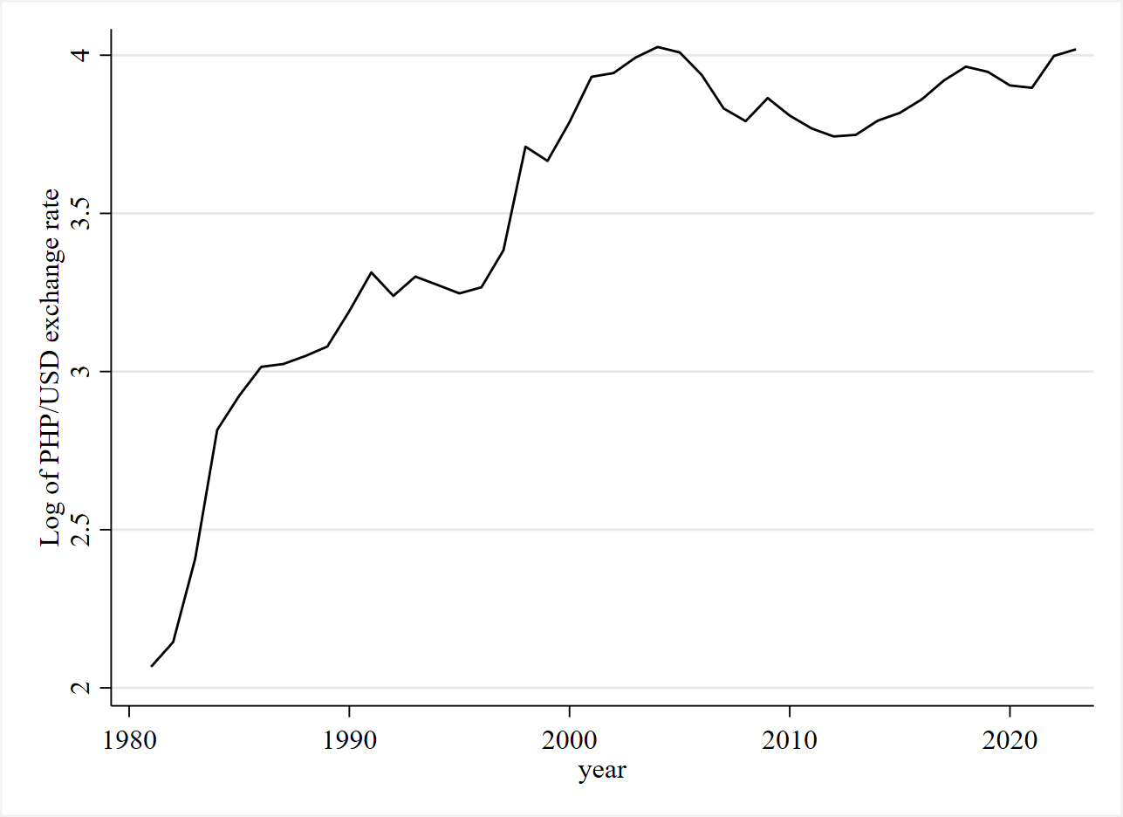
Figure 1e. Log bilateral PHP–USD exchange rate, 1981–2023

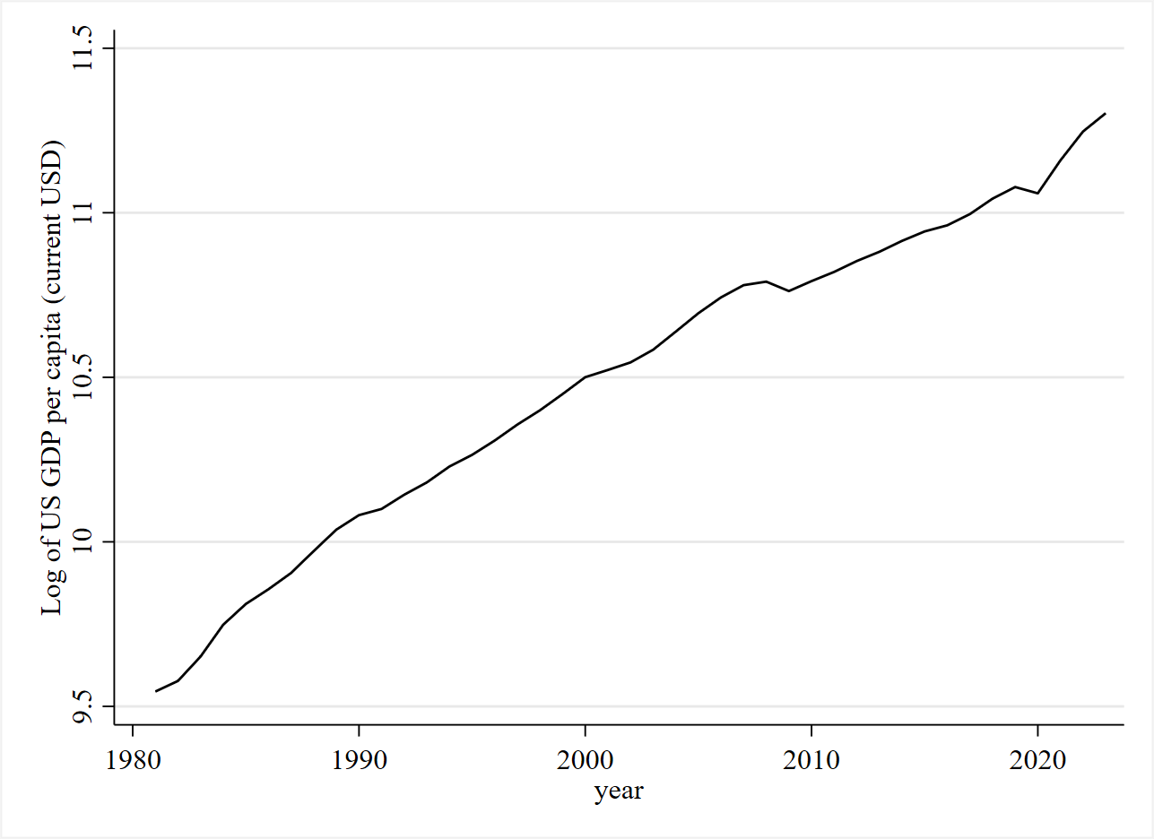
Figure 1f. Log of US real GDP per capita, 1981–2023

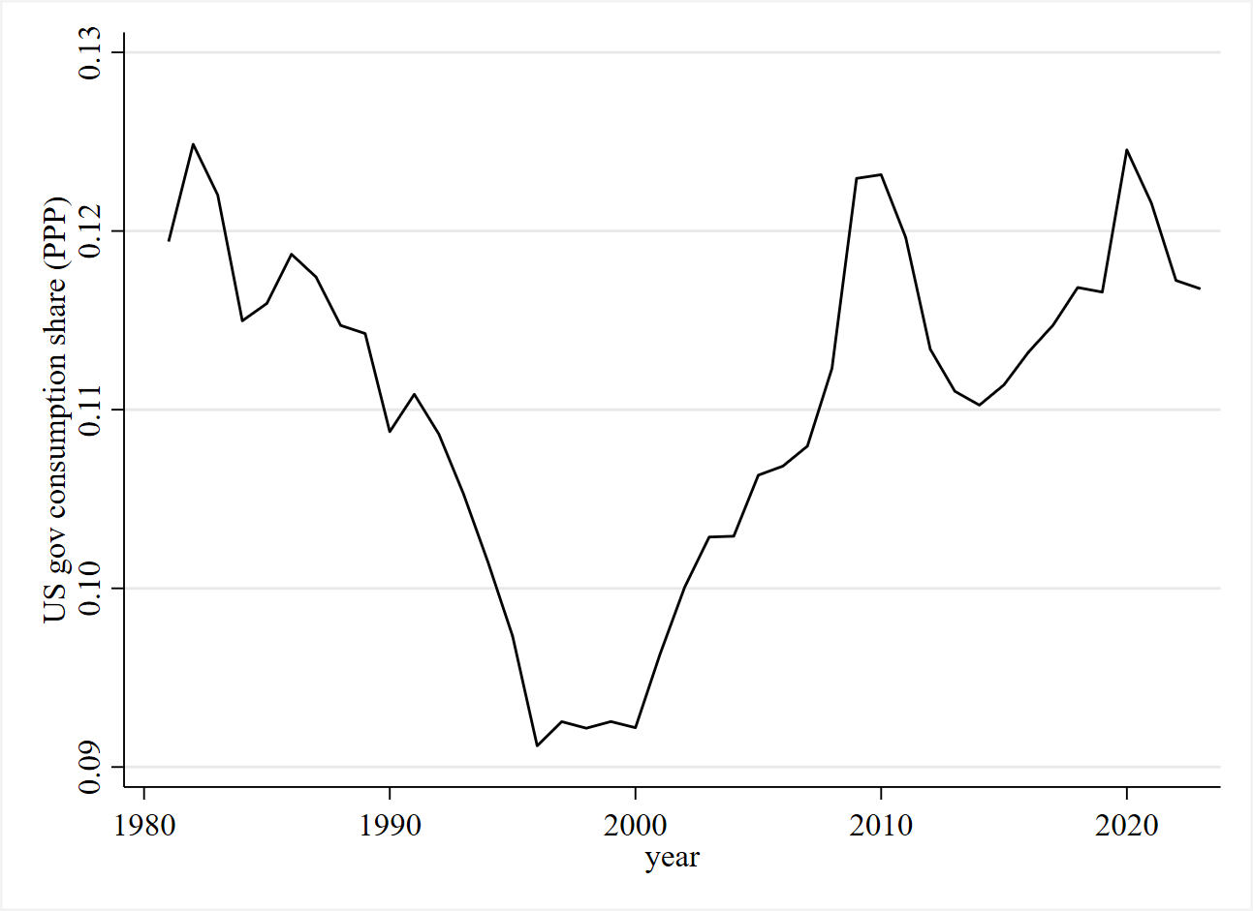
Figure 1g. US government consumption share, 1981–2023

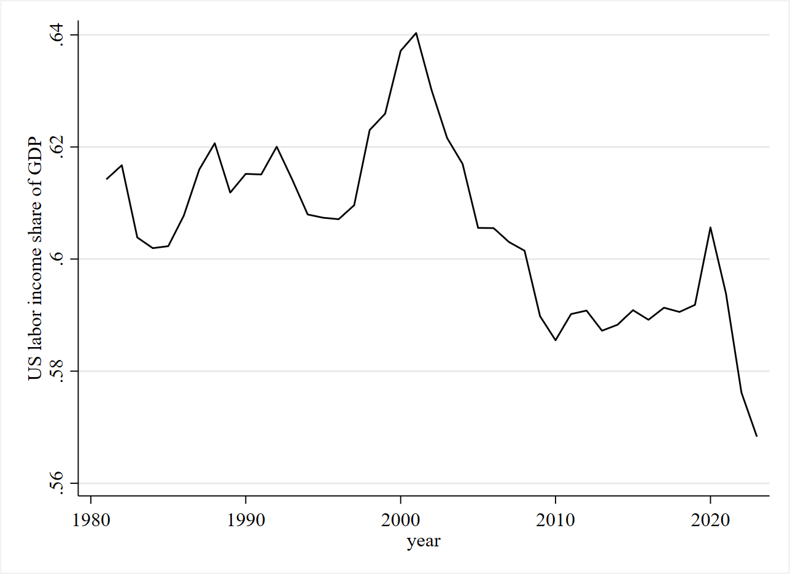
Figure 1h. US labor income share, 1981–2023

Empirical Results
The time-series properties of all variables were examined using Augmented Dickey–Fuller (ADF), Phillips–Perron (PP), and KPSS tests applied to lnM, lnPH_GDP, ph_csg, ph_labsh, lnUS_GDP, us_csg, us_labsh, and lnEXC in levels and first differences. The combined evidence from these tests indicates that all series are non‑stationary in levels but become stationary after first differencing, implying integration of order one, I(1), and ruling out I(2) behavior. This outcome satisfies the key prerequisite for the ARDL bounds‑testing approach, which requires regressors to be at most I(1). Table 1 presents the results of the ADF, Phillips-Perron, and KPSS unit root tests conducted on all variables in both levels and first differences.
Table 1: Unit Root Test Results
Variable | ADF level , const | ADF first diff. | PP level | PP first diff. | KPSS level (max) | KPSS first diff. (max) | Order
lnM | −1.735 | −6.288*** | −2.876** | −5.532*** | 0.236*** | 0.046 | I(1)
lnPH_GDP | −0.238 | −3.631** | 0.330 | −4.914*** | 0.469*** | 0.110 | I(1)
ph_csg | −1.102 | −3.628** | −1.058 | −5.167*** | 0.496*** | 0.237*** | I(1)
ph_labsh | −2.025 | −4.237*** | −1.976 | −5.835*** | 0.539*** | 0.058 | I(1)
lnUS_GDP | −1.582 | −4.072*** | −1.751 | −4.440*** | 0.823*** | 0.176** | I(1)
us_csg | −1.678 | −3.978*** | −1.523 | −4.924*** | 0.776*** | 0.107 | I(1)
us_labsh | −0.873 | −4.044*** | −0.891 | −4.802*** | 0.505*** | 0.062 | I(1)
lnEXC | −2.883* | −3.644** | −3.901*** | −4.216*** | 0.766*** | 0.126 | I(1)
Note: "* p < 0.01, p < 0.05, * p < 0.10. ADF and PP: H0 = unit root (stars indicate rejection of a unit root). KPSS: H0 = trend‑stationarity (stars indicate rejection of stationarity). Lag selection based on AIC with a maximum of 2 lags."
The ADF and Phillips–Perron tests show that for most variables the null of a unit root cannot be rejected in levels but is strongly rejected in first differences. For example, lnM has an ADF statistic of −1.735 (p ≈ 0.41) and a PP statistic of −2.876 at levels—both above the 5% critical value—while its first difference shows very large negative values (ADF −6.288, PP −5.532), highly significant at the 1% level. A similar pattern holds for lnPH_GDP, ph_csg, ph_labsh, lnUS_GDP, us_csg, and us_labsh, where level tests are clearly insignificant but first‑difference tests are significant at least at 5% and usually at 1%. lnEXC is the only borderline case: the ADF with only a constant just crosses the 10% critical value (−2.883) and the PP clearly rejects a unit root in levels, but once a linear trend is included in ADF the statistic (−2.852) lies above even the 10% critical value, so the safer reading is to treat lnEXC as I(1) rather than stationary in levels.
The KPSS results provide confirmatory evidence by reversing the null. In levels, all variables have KPSS statistics well above the 5% critical value at some lag orders—for instance, lnPH_GDP (max ≈ 0.47), lnUS_GDP (≈ 0.82), ph_csg (≈ 0.50), and lnEXC (≈ 0.77)—which implies rejection of the null of trend‑stationarity and is consistent with unit‑root behavior. By contrast, in first differences, KPSS statistics for most variables are comfortably below the 5% critical value (e.g. D.lnM ≈ 0.03–0.05, D.ph_labsh ≈ 0.06, D.us_labsh ≈ 0.05), so the null of (trend) stationarity cannot be rejected. Two series, D.ph_csg and D.lnUS_GDP, sit closer to the 5%–2.5% thresholds (max ≈ 0.237 and 0.176 respectively), which suggests some residual persistence but still much stronger evidence of stationarity than in levels.
Overall, the concordance between ADF, PP, and KPSS supports a clear classification of all variables as integrated of order one, I(1): they are non‑stationary in levels but become stationary after first differencing, and there is no indication that any series is I(2). This conclusion is crucial because the ARDL bounds‑testing procedure of Pesaran et al. requires that none of the regressors be I(2), and so the unit‑root diagnostics confirm that the subsequent ARDL models and bounds tests are applied in an appropriate setting.
To test for the existence of a long‑run equilibrium relationship between migration and its determinants, the analysis applies the Pesaran, Shin, and Smith (2001) bounds testing procedure to a set of autoregressive distributed lag (ARDL) specifications. The bounds test evaluates whether the joint significance of lagged levels (F‑statistic) and the error‑correction t‑statistic are sufficiently extreme relative to finite‑sample critical values to reject the null hypothesis of “no level relationship.” Because all variables are I(0) or I(1) and none is I(2), the bounds framework is appropriate, and it provides a unified way to assess cointegration across the seven theoretically motivated model specifications. Table 2 presents the seven model specifications for bounds test.
Table 2. Model specifications and finite‑sample cases
 | Model | Dependent variable | Independent variables | Finite‑sample case | Selected ARDL order (p, q’s)
1 | Baseline PH push + EXC | lnM | lnPH_GDP, ph_csg, lnEXC | 3 variables, 41 observations | ARDL(2,1,0,1)
2 | Bilateral PH push + US pull | lnM | lnPH_GDP, ph_csg, lnUS_GDP, us_csg, lnEXC | 5 variables, 41 observations | ARDL(2,2,0,0,0,1)
3 | Income‑only | lnM | lnPH_GDP, lnUS_GDP | 2 variables, 41 observations | ARDL(2,1,1)
4 | PH labor share | lnM | lnPH_GDP, ph_csg, ph_labsh, lnEXC | 4 variables, 41 observations | ARDL(2,1,0,1,1)
5 | US labor share | lnM | lnPH_GDP, ph_csg, us_labsh, lnEXC | 4 variables, 41 observations | ARDL(2,1,0,0,1)
6 | Dynamic regression with Newey–West HAC | lnM | L.lnM, lnPH_GDP, ph_csg, lnUS_GDP, us_csg, lnEXC | Not ARDL/bounds (Newey‑West OLS) | N/A
7 | Baseline + COVID dummy (2020–2021) | lnM | lnPH_GDP, ph_csg, lnEXC, covid | 4 variables, 41 observations | ARDL(1,2,2,0,0)

The baseline push‑factor model (Model 1) yields an F‑statistic of 6.478 and a t‑statistic of −4.544, both exceeding the finite‑sample I(1) critical values at the 5% level, which provides clear evidence of a long‑run level relationship between Philippine emigration, domestic income, government consumption share, and the exchange rate. The bilateral push–pull specification (Model 2) also rejects the null of no level relationship, with F = 5.998 and t = −4.721, indicating that once US income and spending are added, migration, PH, and US macro variables still form a cointegrated system, even though individual long‑run coefficients are affected by multicollinearity. In contrast, the income‑only model (Model 3) fails the bounds test: its F‑statistic of 2.754 lies below the I(0) lower bound and the associated t‑statistic is too close to zero, so the null of no long‑run relationship cannot be rejected, implying that bilateral GDP levels alone do not generate a cointegrating migration equation. The inequality‑augmented domestic model (Model 4) with Philippine labor share again produces F and t statistics above the I(1) upper bounds, supporting cointegration and reinforcing the role of domestic push and distributional variables in the long run.
The US labor‑share model (Model 5) also rejects the null at conventional levels, but with a somewhat weaker t‑statistic, suggesting a cointegrating relationship that is less tightly pinned down and more sensitive to specification. Finally, the COVID‑augmented baseline (Model 7) delivers extremely large F and t statistics (39.811 and −11.454), far beyond the 1% critical values, indicating a very strong long‑run relationship that incorporates a sizeable negative structural break during the pandemic without overturning the underlying equilibrium. Overall, the bounds tests show that theory‑consistent models including domestic push and crisis terms admit a stable long‑run migration equilibrium, while the neoclassical income‑only specification does not. The results of the bounds tests are presented in table 3.
Table 3. Bounds test summary
Model | F‑statistic | t‑statistic | Decision (5%) | Cointegration
1 | 6.478*** | −4.544** | F and t > I(1) upper bounds for k = 3 | Yes
2 | 5.998*** | −4.721** | F and t > I(1) upper bounds for k = 5 | Yes
3 | 2.754 | −2.204 | F < I(0) lower bound for k = 2 | No
4 | 5.884*** | −4.591** | F and t > I(1) upper bounds for k = 4 | Yes
5 | 5.742*** | −3.959* | F > I(1) at 5%; t between I(0) and I(1) for k = 4 | Yes
7 | 39.811*** | −11.454*** | Far above I(1) bounds for k = 4 | Yes
Note: Critical values from Pesaran, Shin, and Smith (2001), Case III (unrestricted intercept, no trend). * p < 0.01, p < 0.05. 5% critical values for k = 3: I(0) = 3.23, I(1) = 4.35. TBD entries to be completed with actual Stata output.
Following the unit root and bounds tests, the analysis estimates autoregressive distributed lag (ARDL) error‑correction models for each of the seven specifications to obtain long‑run and short‑run coefficients. The ARDL framework is appropriate given the I(1)–I(0) mix and the evidence of cointegration, and it allows the decomposition of dynamics into a long‑run equilibrium component and short‑run adjustments. The discussion below focuses on the long‑run coefficients for those models where the bounds test indicated a valid level relationship. The table below reports long‑run coefficients from the ARDL‑ECM for the models where the bounds test supports cointegration (Models 1, 2, 4, 5, and 7). Model 3 is excluded because the bounds test rejects a long‑run relationship; Model 6 is not an ARDL model.
Table 4. Long‑run coefficients (cointegrated models)
Variable | Model 1 | Model 2 | Model 4 | Model 5 | Model 7
lnPH_GDP | −0.458** | 0.942 (Insig) | −0.807** | −0.872** | −0.266**
ph_csg | −6.416** | −6.263** | −8.651*** | −4.876 (Insig) | −3.413**
ph_labsh | — | — | 7.093 (Insig) | — | —
lnUS_GDP | — | −2.872* | — | — | —
us_csg | — | −8.209 (Insig) | — | — | —
us_labsh | — | — | — | −13.948 (Insig) | —
lnEXC | −0.030 (Insig) | 1.177 (Insig) | 0.290 (Insig) | 0.366 (Insig) | −0.059 (Insig)
covid | — | — | — | — | −1.768***
Note: * p < 0.01, p < 0.05, * p < 0.10. Long‑run coefficients derived from the ARDL error‑correction model. “—” indicates that the variable is not included in the specification. “Insig” indicates that the coefficient is not statistically significant at conventional levels.

In the baseline domestic push model (Model 1), higher Philippine GDP per capita and a higher PH government consumption share are both associated with significantly lower long‑run emigration: the elasticities are −0.46 and −6.42, respectively, while the exchange rate has no statistically meaningful long‑run effect. When US variables are added (Model 2), the long‑run coefficients on lnPH_GDP and lnUS_GDP lose conventional significance and flip in sign (lnPH_GDP positive, lnUS_GDP negative at the 10% level), and us_csg and lnEXC remain insignificant, consistent with the earlier evidence of severe multicollinearity among income and exchange‑rate series.

The PH labor‑share model (Model 4) reinforces the domestic push story: lnPH_GDP and ph_csg remain significantly negative in the long run, while the level of ph_labsh itself is positive but not significant, suggesting that inequality effects operate more clearly in the short run rather than through the long‑run equilibrium level. The US labor‑share model (Model 5) again shows a significantly negative PH income coefficient, but the US inequality term (us_labsh) is large and imprecisely estimated, and PH spending and the exchange rate are not statistically significant in the long run, providing little support for a robust foreign‑inequality pull channel.

Finally, the COVID‑augmented baseline (Model 7) preserves the negative long‑run effects of PH income and PH government consumption while adding a large and highly significant negative level shift from the pandemic dummy (−1.77), indicating that COVID sharply depressed migration relative to the underlying equilibrium. Across all cointegrated specifications, the most stable and consistently significant long‑run determinants of emigration are domestic macro push factors—Philippine GDP per capita and PH government consumption share—while long‑run roles for US variables, labor‑share measures, and the exchange rate are weak or statistically fragile.

Short‑run dynamics are summarized by the error‑correction term (ECT) and the coefficients on first differences and their lags in the ARDL‑ECM. For the cointegrated specifications, the short‑run results show rapid adjustment back to equilibrium and sizable short‑run effects of Philippine GDP growth and, in several cases, the exchange rate.

Table 5. Short‑run coefficients and error‑correction term
Variable | Model 1 | Model 2 | Model 4 | Model 5 | Model 7
ECT (L1.lnM) | −0.620*** | −1.002*** | −0.592*** | −0.559*** | −0.812***
ΔlnM (LD) | 0.377*** | 0.532*** | 0.303** | 0.291* | —
ΔlnM (L2D) | — | — | — | — | −0.203** (LD)
ΔlnPH_GDP (D1) | 3.144*** | 2.878*** | 3.263*** | 2.790*** | 0.763***
ΔlnPH_GDP (LD) | — | 0.764 (Insig) | — | — | 0.406 (Insig)
Δph_csg (D1) | — | — | 5.471** | — | 3.524 (Insig)
Δph_csg (LD) | — | — | — | — | 5.061*
Δph_csg (L2D) | — | — | −10.368* | — | —
Δph_labsh (D1) | — | — | −9.276** | — | —
ΔlnUS_GDP (D1) | — | 3.766 (Insig) | — | — | —
Δus_csg (D1) | — | — | — | — | —
Δus_labsh (D1) | — | — | — | — | —
ΔlnEXC (D1) | 2.142** | 1.516* | 2.046** | 1.872** | —
ΔlnEXC (D1) alt spec | — | — | — | — | −0.524**
Δcovid (D1) | — | — | — | — | —
Δafc (D1) | — | — | — | — | —
Note: * p < 0.01, p < 0.05, * p < 0.10. ECT = error-correction term (coefficient on L1.lnM in the ECM). Delta (Δ) denotes first difference. LD and L2D denote lagged first differences selected in the ARDL specification. “—” indicates that the variable or lag is not included or not selected. “Insig” indicates that the coefficient is not statistically significant at conventional levels.

Across all cointegrated models, the ECT coefficients are negative and highly significant, with magnitudes between −0.56 and −1.00, indicating that between roughly 56% and more than 100% of any deviation from the long‑run equilibrium in migration is corrected within one year, implying fast and sometimes slightly overshooting adjustment. The lagged change in lnM is generally positive and significant (except in Model 7’s alternative specification), pointing to short‑run persistence in migration changes.

Short‑run changes in Philippine GDP per capita (ΔlnPH_GDP) are strongly positive and highly significant in all models, suggesting that growth spurts in domestic income are associated with higher contemporaneous increases in emigration, even though the long‑run level effect of income is negative. Exchange‑rate changes (ΔlnEXC) also display significant short‑run effects in most specifications, with positive coefficients in Models 1, 2, 4, and 5, and a negative effect in the crisis‑augmented specification, indicating that currency movements matter for year‑to‑year migration adjustments.

Short‑run inequality channels appear mainly through Philippine labor share in Model 4, where Δph_labsh is significantly negative, consistent with higher labor income share reducing short‑run migration pressures, while crisis‑related dummies influence adjustment more through level shifts in the long‑run part of the ECM than through differenced terms. Overall, the short‑run results emphasize rapid error correction toward a domestic push‑driven long‑run equilibrium, with transient dynamics dominated by domestic GDP growth, migration inertia, and exchange‑rate movements.

CUSUM tests show stable coefficients for all ARDL specifications as shown in Table 6. Across all candidate ARDL specifications, the recursive CUSUM statistics lie far below the 5% critical boundary, indicating parameter stability over 1983–2023 for the baseline, bilateral, inequality, and COVID‑augmented models. This supports the interpretation that the estimated long‑run relationships and short‑run dynamics are not driven by unmodelled structural breaks, even in the presence of major events such as the Asian Financial Crisis and the COVID‑19 pandemic.

Table 6. CUSUM stability tests
Model | CUSUM statistic | 5% critical value | Stability decision
1 | 0.2782 | 0.9479 | Stable (no break)
2 | 0.3748 | 0.9479 | Stable (no break)
4 | 0.2559 | 0.9479 | Stable (no break)
5 | 0.4025 | 0.9479 | Stable (no break)
7 | 0.0641 | 0.9479 | Stable (no break)
Note: All CUSUM test statistics are well below the 5% critical value, so the null of no structural break cannot be rejected in any model. Values from estat sbcusum on OLS regressions mirroring each ARDL specification.
Variance inflation factors (VIFs) are used to assess whether multicollinearity among the long‑run regressors is severe enough to distort coefficient estimates in the ARDL models. In this application, VIFs are computed from two OLS regressions that mirror the long‑run sets used in the cointegrated specifications: a “PH‑only” regression including Philippine GDP per capita, government consumption share, labor share, and the exchange rate, and a “bilateral” regression that adds US GDP per capita and US government consumption share to the PH variables and the exchange rate. This design keeps the focus on the structural long‑run regressors that enter the ARDL cointegrating vectors, rather than on short‑run differences or crisis dummies.

Table 7. VIF matrix
Variable | PH‑only regression (lnM on lnPH_GDP, ph_csg, ph_labsh, lnEXC) | Bilateral regression (lnM on lnPH_GDP, ph_csg, lnUS_GDP, us_csg, lnEXC)
lnPH_GDP | 5.10 | 81.23
ph_csg | 2.75 | 3.95
ph_labsh | 2.22 | —
lnUS_GDP | — | 242.36
us_csg | — | 2.11
lnEXC | 3.43 | 82.47
Note: “—” indicates variable not included in that regression, so VIF is not defined. Mean VIF is 3.37 for the PH‑only regression and 82.42 for the bilateral regression.

For the PH‑only regression, VIFs for lnPH_GDP, ph_csg, ph_labsh, and lnEXC range from about 2.2 to 5.1, with a mean VIF of 3.37, which is well below common rule‑of‑thumb thresholds (typically VIF > 10) used to flag problematic multicollinearity. This indicates that domestic long‑run regressors are correlated but not so highly as to make their coefficients unreliable or uninterpretable, consistent with the relatively precise and stable long‑run estimates obtained in the baseline PH push and PH inequality ARDL models.

By contrast, in the bilateral regression, the VIFs for lnUS_GDP, lnEXC, and lnPH_GDP explode to approximately 242, 82, and 81, respectively, while ph_csg and us_csg remain in a moderate range (around 2–4), and the mean VIF rises to 82.42. These values signal extreme multicollinearity between domestic income, US income, and the exchange rate, meaning that these three variables contain almost the same linear information and cannot be separately identified with precision in the long‑run equation. This diagnostic finding aligns with the empirical results from the ARDL push–pull and foreign‑inequality models, where long‑run coefficients on income and exchange‑rate terms are large but imprecise and sometimes unstable across specifications, and it justifies placing greater weight on the better‑behaved PH‑only models when drawing substantive conclusions about long‑run migration determinants.

Diagnostic Tests
Table 8. Diagnostic tests for ARDL models
Model | BG LM χ² (lags 1–2) | Serial corr | BP  χ²(1) | Heterosked | RESET F | Functional form | Normality χ²(2) | Normal errors?
1 | 0.05; 2.31 | No | 25.73*** | No | 37.93*** | No | 21.22*** | No
2 | 0.25; 3.53 | No | 29.13*** | No | 29.20*** | No | 15.18*** | No
4 | 0.59; 3.63 | No | 19.92*** | No | 24.26*** | No | 12.21*** | No
5 | 0.07; 0.63 | No | 22.02*** | No | 32.55*** | No | 20.96*** | No
7 | 0.44; 1.63 | No | 0.00 | Yes | 3.04** | Weakly No | 3.92 | Yes
Note: “BG LM χ² (lags 1–2)” reports the two LM statistics for lag 1 and lag 2 (all with p > 0.10 so non‑significant). “Serial corr?” = whether BG rejects H0 of no serial correlation. “Heterosked?” = whether BP rejects H0 of homoskedasticity. “Functional form OK?” = whether RESET fails to reject H0 of no omitted non‑linear terms. “Normal errors?” = whether the skewness–kurtosis test fails to reject normality. Stars indicate significance of the test statistic at conventional levels: * p < 0.01, p < 0.05, * p < 0.10.

For all reported models (1, 2, 4, 5, 7), the Breusch–Godfrey LM statistics at lags 1 and 2 are small and have p‑values above 0.10, so there is no evidence of residual serial correlation in any specification. In contrast, the Breusch–Pagan tests indicate clear heteroskedasticity for Models 1, 2, 4, and 5 (large χ² with p < 0.01), while Model 7 strongly supports homoskedasticity (χ² ≈ 0, p ≈ 1), so only the COVID‑augmented baseline meets the constant‑variance assumption.

The Ramsey RESET statistics are highly significant for Models 1, 2, 4, and 5, implying omitted non‑linear terms or mis‑specification in these specifications, whereas Model 7 shows a borderline rejection at the 5% level, suggesting milder but still non‑negligible functional‑form issues. Normality tests on ARDL residuals reject Gaussian errors for Models 1, 2, 4, and 5 (χ²(2) significant at the 1% level), but do not reject for Model 7, where the joint skewness‑kurtosis statistic is small and the p‑value around 0.14. Taken together, these diagnostics show that all preferred models are free of serial correlation, but most suffer from heteroskedasticity, non‑normal residuals, and RESET‑type mis‑specification, with the COVID‑augmented baseline (Model 7) standing out as the best‑behaved in terms of variance stability and error normality.

